EXPANDING AND FACTORIZING
Pearson Edexcel - Monday 6 November 2017 - Paper 2 (Calculator) Higher Tier
1.
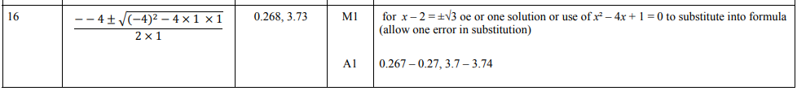
Pearson Edexcel - Specimen Papers Set 1 - Paper 3 (Calculator) Higher Tier
2.
Pearson Edexcel - Sample Paper 1 - (Non-Calculator) Higher Tier
3.
Pearson Edexcel - Sample Paper 1 - (Non-Calculator) Higher Tier
4.
Pearson Edexcel - Thursday 9 June 2016 - Paper 2 (Calculator) Higher Tier
5.
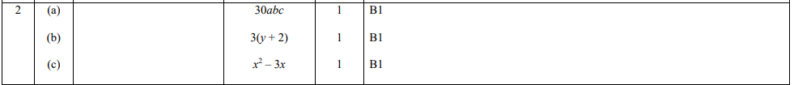
Pearson Edexcel - Wednesday 4 November 2015 - Paper 1 (Non-Calculator) Higher Tier
6.
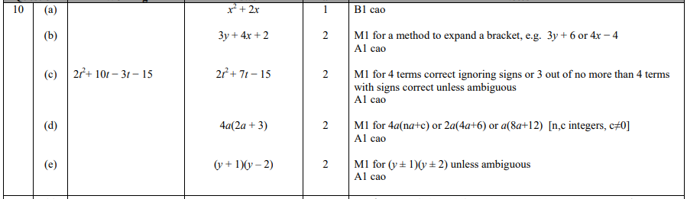
Pearson Edexcel - Monday 8 June 2015 - Paper 2 (Calculator) Higher Tier
7.
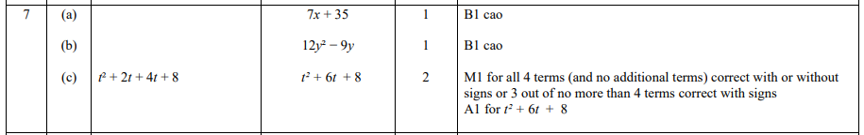
Pearson Edexcel - Wednesday 5 November 2014 - Paper 1 (Non-Calculator) Higher Tier
8.
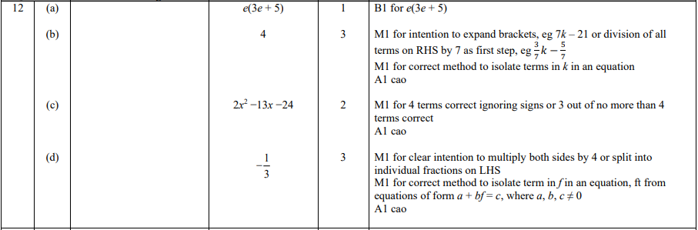
Pearson Edexcel - Monday 9 June 2014 - Paper 1 (Non-Calculator) Higher Tier
9.
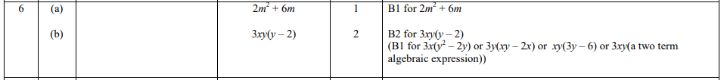
Pearson Edexcel - Monday 9 June 2014 - Paper 1 (Non-Calculator) Higher Tier
10.
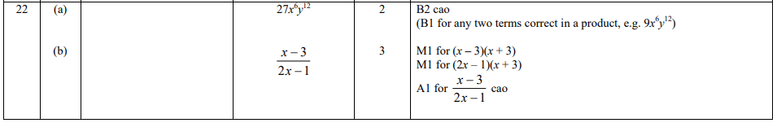
Pearson Edexcel - Wednesday 6 November 2013 - Paper 1 (Non-Calculator) Higher Tier
11.
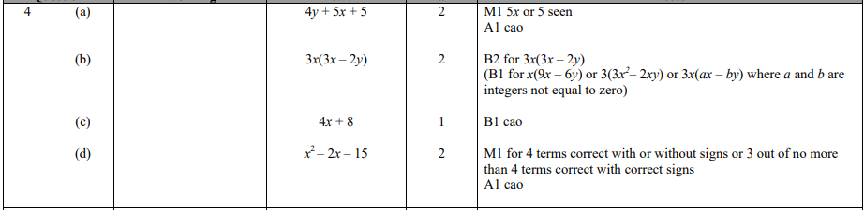
Pearson Edexcel - Tuesday 11 June 2013 - Paper 1 (Non-Calculator) Higher Tier
12.
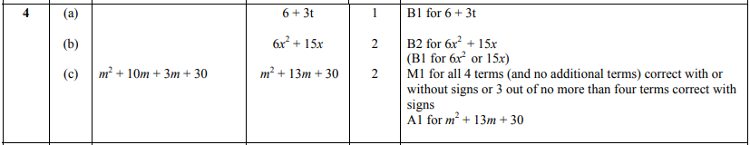
Pearson Edexcel - Friday 14 June 2013 - Paper 2 (Calculator) Higher Tier
13.
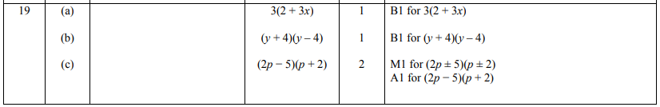
Pearson Edexcel - Thursday 28 February 2013 - Paper 1 (Non-Calculator) Higher Tier
14.
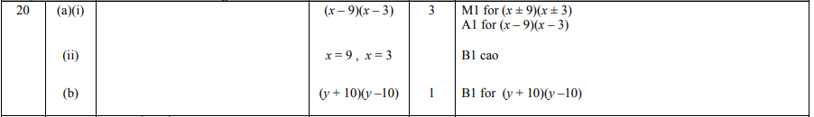
Pearson Edexcel - Monday 4 March 2013 - Paper 2 (Calculator) Higher Tier
15.
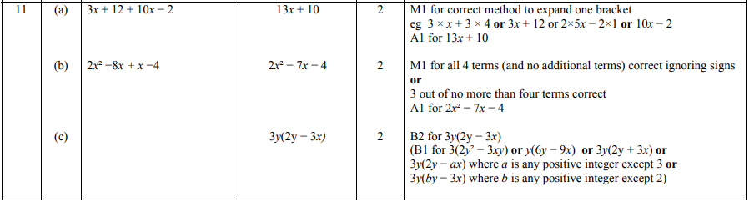
Pearson Edexcel - Tuesday 6 November 2012 - Paper 1 (Non-Calculator) Higher Tier
16.
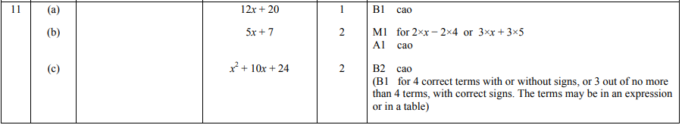
Pearson Edexcel - Thursday 8 November 2012 - Paper 2 (Calculator) Higher Tier
17.
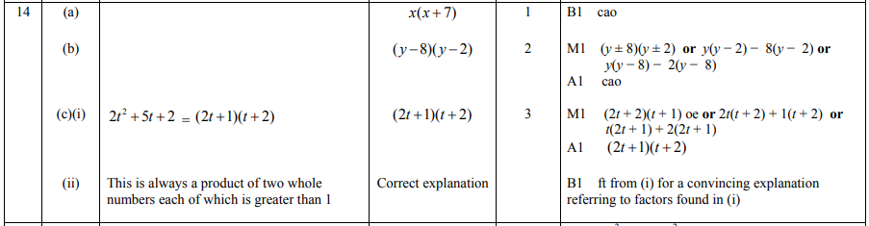
Pearson Edexcel - Monday 11 June 2012 - Paper 1 (Non-Calculator) Higher Tier
18.
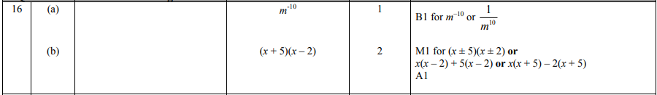

Pearson Edexcel - Monday 11 June 2012 - Paper 1 (Non-Calculator) Higher Tier
19.
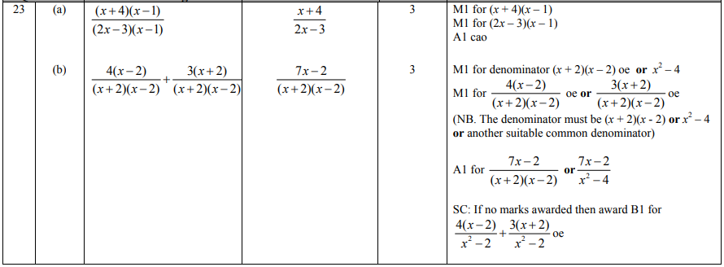
Pearson Edexcel - Wednesday 13 June 2012 - Paper 2 (Calculator) Higher Tier
20.
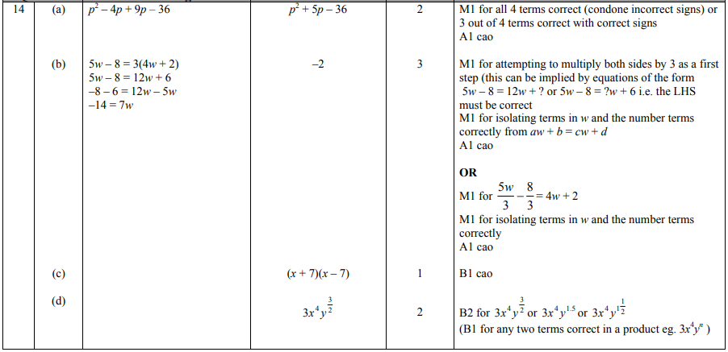
Pearson Edexcel - Friday 2 March 2012 - Paper 3 (Non-Calculator) Higher Tier
21.
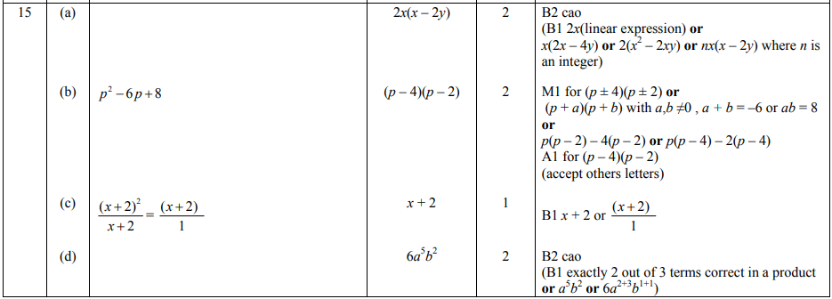
Pearson Edexcel - Monday 5 March 2012 - Paper 4 (Calculator) Higher Tier
22.
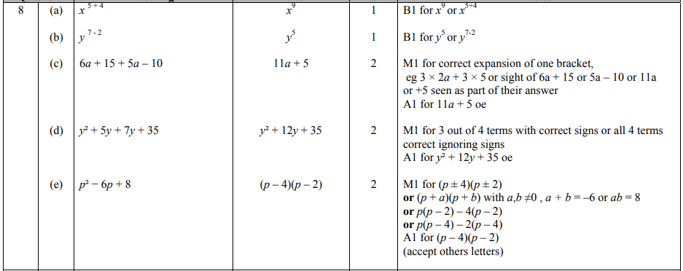
Pearson Edexcel - Wednesday 9 November 2011 - Paper 3 (Non-Calculator) Higher Tier
23.
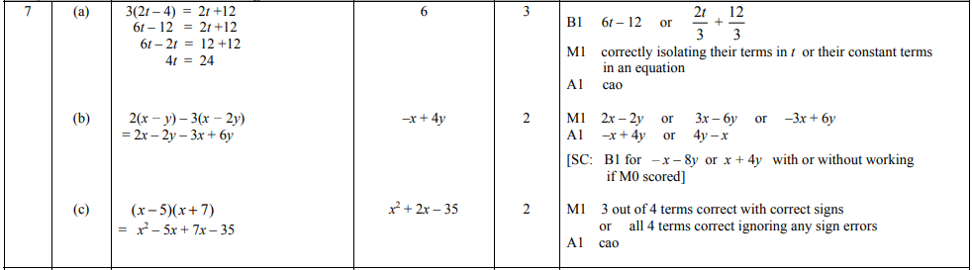
Pearson Edexcel - Monday 14 November 2011 - Paper 4 (Calculator) Higher Tier
24.
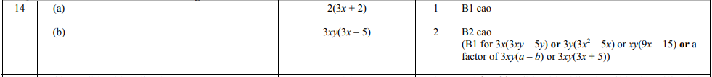
Pearson Edexcel - Monday 14 November 2011 - Paper 4 (Calculator) Higher Tier
25.
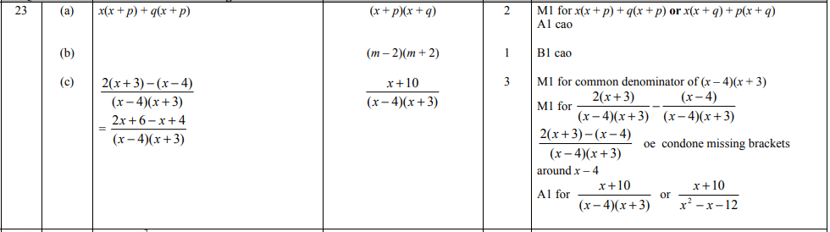
Pearson Edexcel - Monday 6 June 2011 - Paper 3 (Non-Calculator) Higher Tier
26.
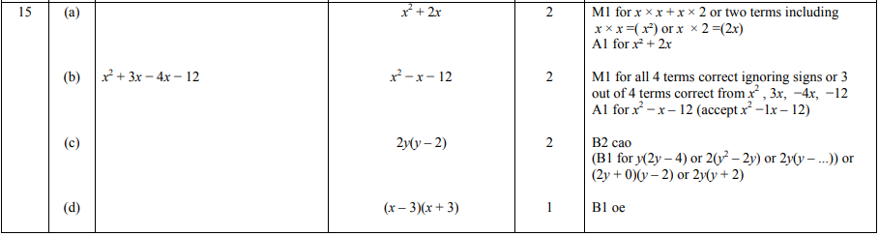
Pearson Edexcel - Tuesday 9 November 2010 - Paper 3 (Non-Calculator) Higher Tier
27.
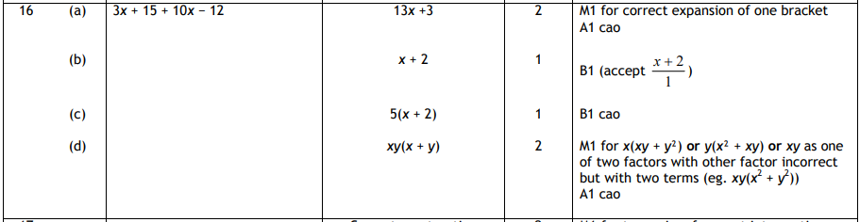
Pearson Edexcel - Monday 7 June 2010 - Paper 3 (Non-Calculator) Higher Tier
28.
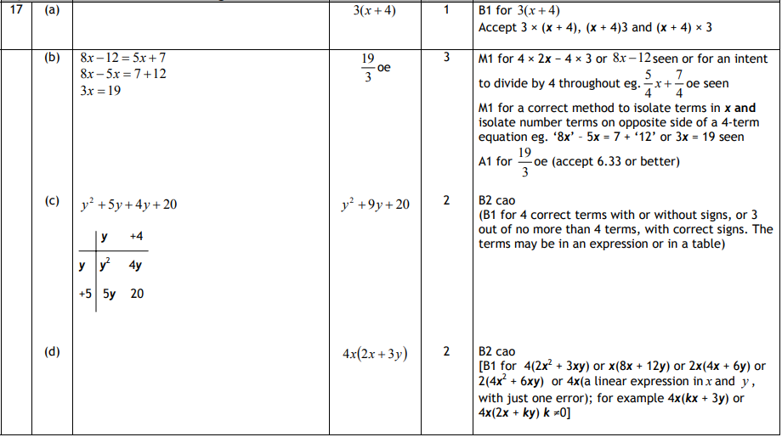
Pearson Edexcel - Friday 11 June 2010 - Paper 4 (Calculator) Higher Tier
29.
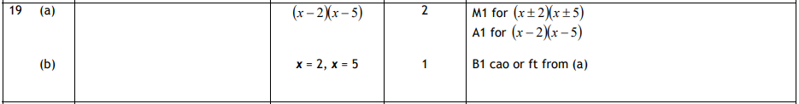
Pearson Edexcel - Thursday 5 November 2009 - Paper 3 (Non-Calculator) Higher Tier
30.
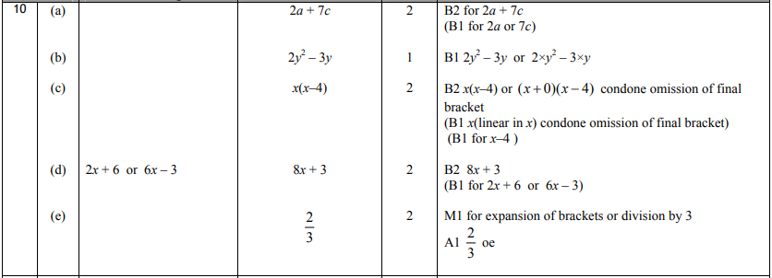
OCR GSCE – Tuesday 3 November 2020 – Paper 4 (Calculator) Higher Tier
31.
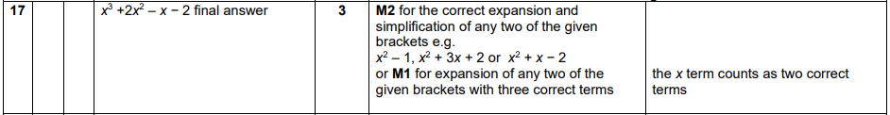
OCR GSCE – Tuesday 5 November 2019 – Paper 4 (Calculator) Higher Tier
32.
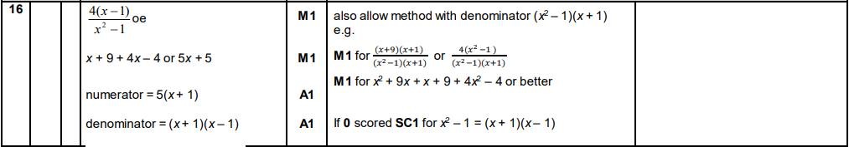
OCR GSCE – Thursday 7 November 2019 – Paper 5 (Non-Calculator) Higher Tier
33.
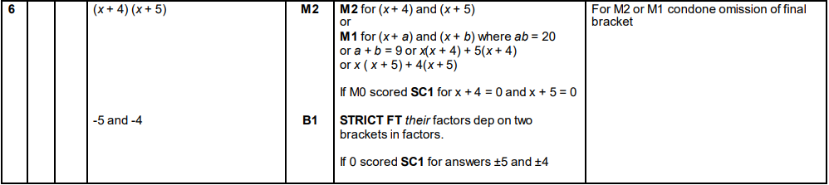
OCR GSCE – Tuesday 21 May 2019 – Paper 4 (Calculator) Higher Tier
34.
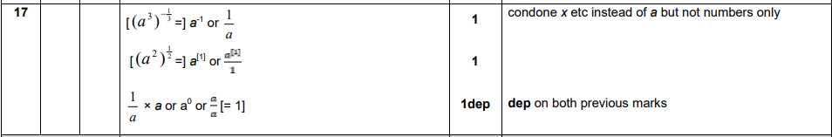
OCR GSCE – Tuesday 11 June 2019 – Paper 6 (Calculator) Higher Tier
35.
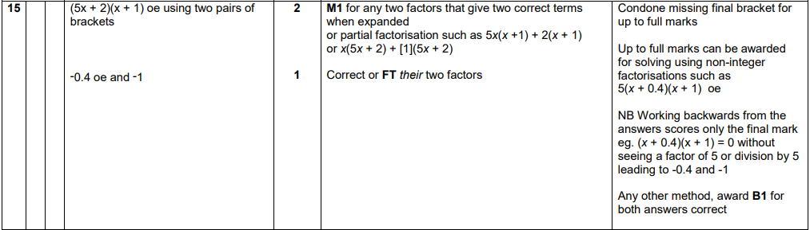
OCR GSCE – Tuesday 6 November 2018 – Paper 4 (Calculator) Higher Tier
36.
OCR GSCE – Monday 12 November 2018 – Paper 6 (Calculator) Higher Tier
37.
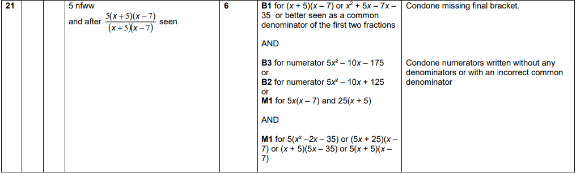
OCR GSCE – Thursday 24 May 2018 – Paper 4 (Calculator) Higher Tier
38.
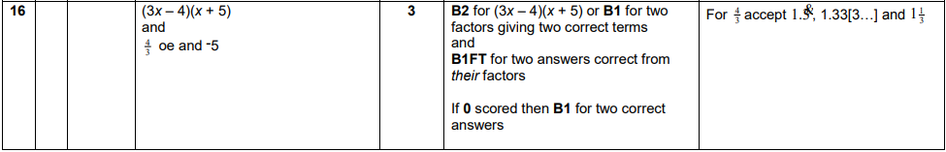

OCR GSCE – Thursday 7 June 2018 – Paper 5 (Non - Calculator) Higher Tier
39.
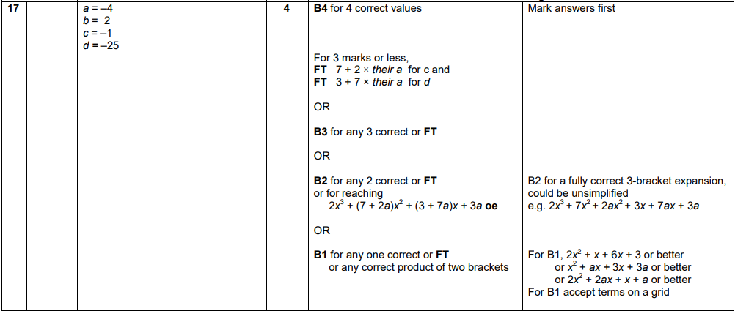
OCR GSCE – Tuesday 12 June 2018 – Paper 6 (Calculator) Higher Tier
40.
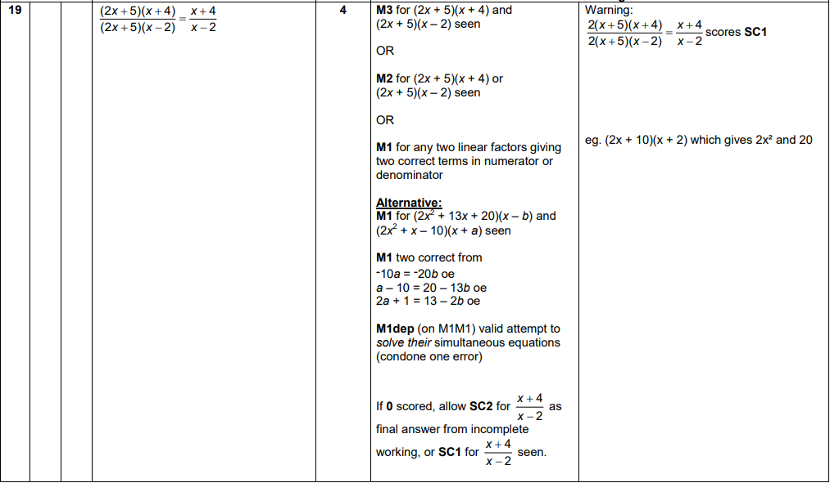

OCR GSCE – Tuesday 2 November 2017 – Paper 4 (Calculator) Higher Tier
41.
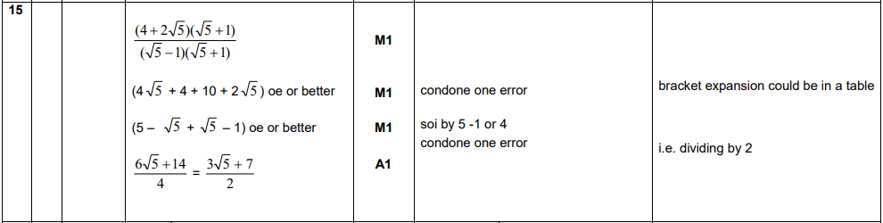
OCR GSCE – Thursday 25 May 2017 – Paper 4 (Calculator) Higher Tier
42.
OCR GSCE – Thursday 8 June 2017 – Paper 5 (Non - Calculator) Higher Tier
43.
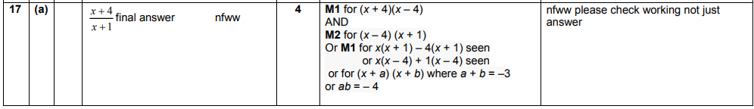
AQA GSCE – Tuesday 19 May 2020 – Paper 1 (Non - Calculator) Higher Tier
44.
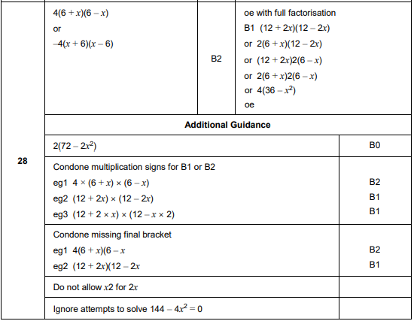
AQA GSCE – Thursday 4 June 2020 – Paper 2 (Calculator) Higher Tier
45.
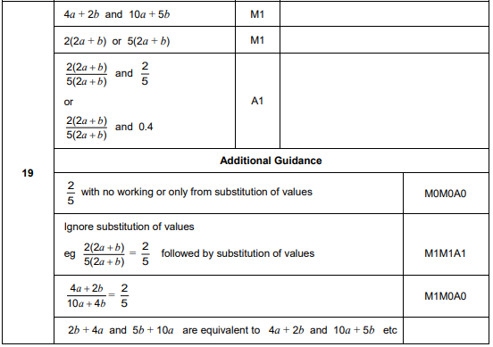
AQA GSCE – Thursday 4 June 2020 – Paper 2 (Calculator) Higher Tier
46.
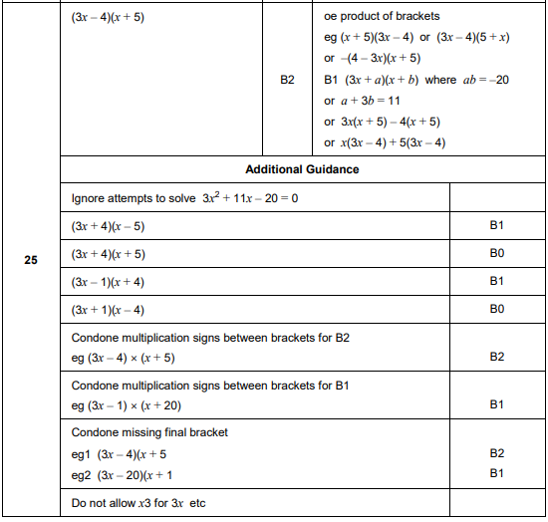
AQA GSCE – Thursday 8 June 2020 – Paper 3 (Calculator) Higher Tier
47.
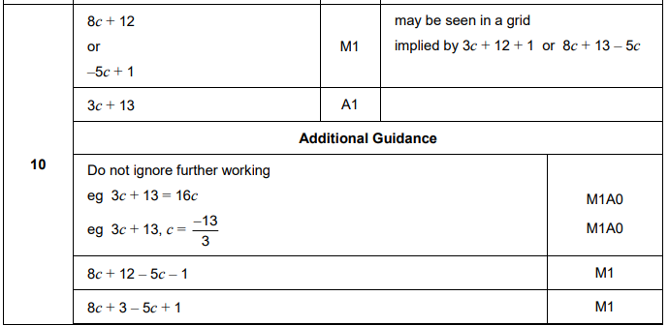
AQA GSCE – Tuesday 21 May 2019 – Paper 1 (Non - Calculator) Higher Tier
48.
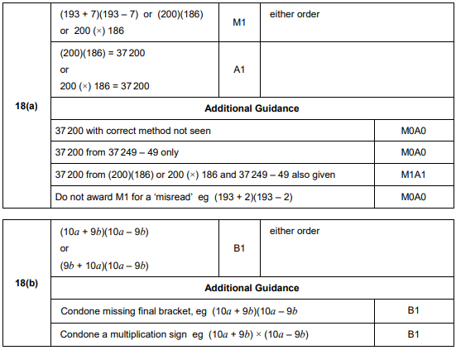

AQA GSCE – Thursday 6 June 2019 – Paper 2 (Calculator) Higher Tier
49.
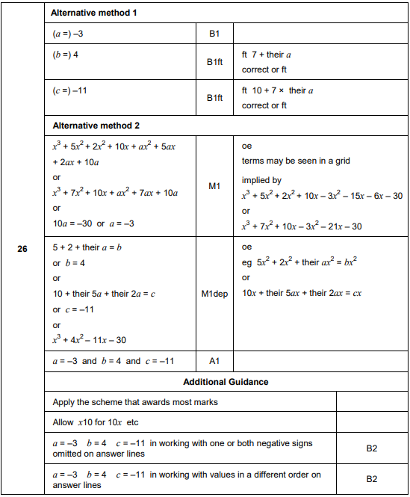
AQA GSCE – Monday 24 May 2018 – Paper 1 (Non - Calculator) Higher Tier
50.
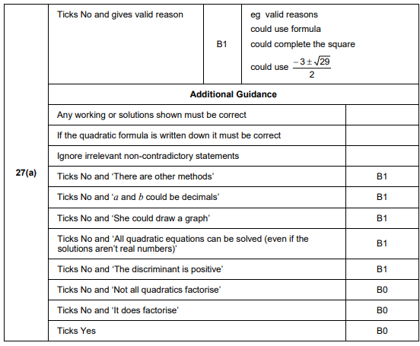
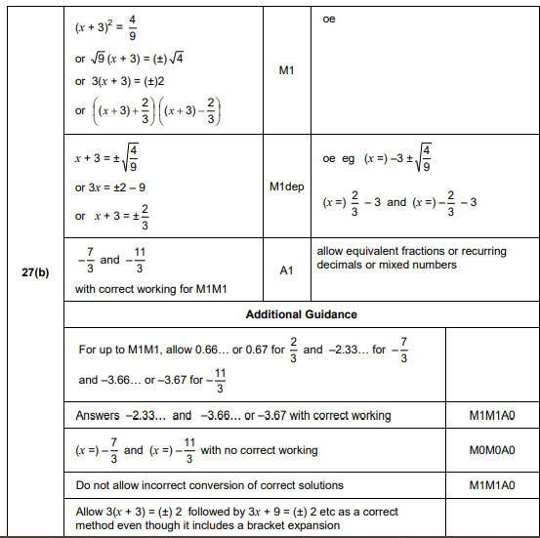
AQA GSCE – Monday 24 May 2018 – Paper 1 (Non - Calculator) Higher Tier
51.
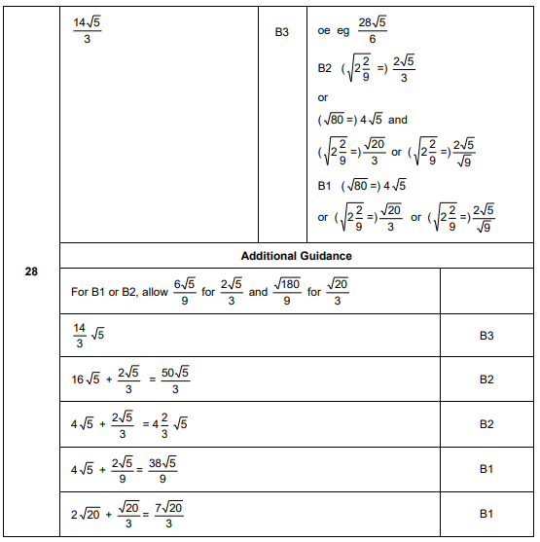
AQA GSCE – Thursday 6 November 2017 – Paper 2 (Calculator) Higher Tier
52.
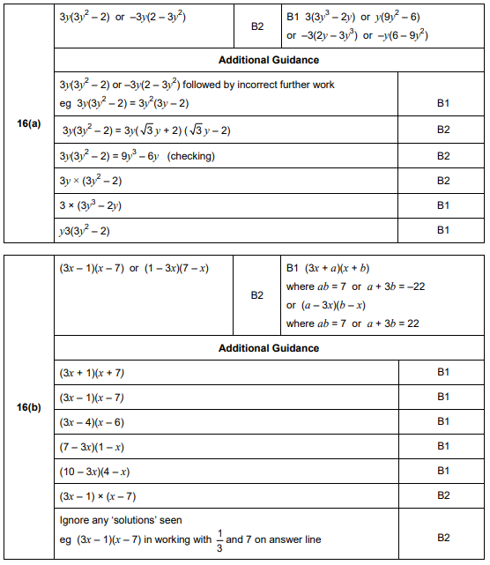
AQA GSCE – Wednesday 8 November 2017 – Paper 3 (Calculator) Higher Tier
53.
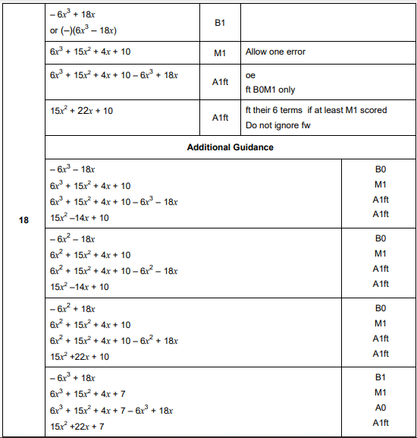
AQA GSCE – Wednesday 25 May 2017 – Paper 1 (Non - Calculator) Higher Tier
54.
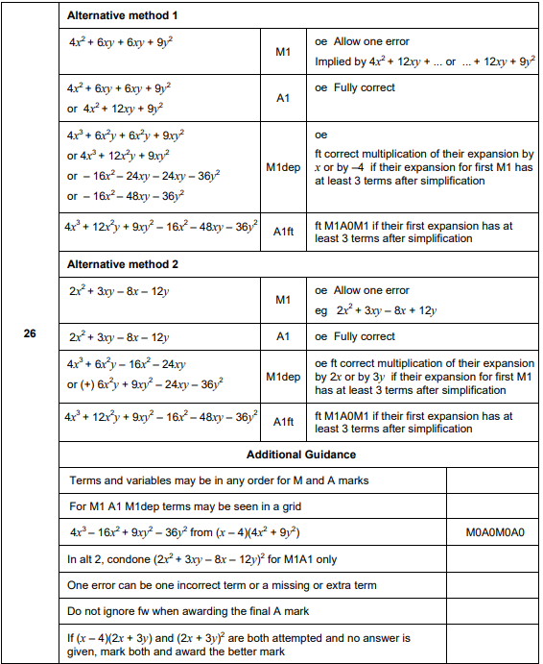
AQA GSCE – Sample Paper 3 (Calculator) Higher Tier
55.
